FALL 2026–2027 • BASIC OPENGL LAB

Regular Circle Drawing in OpenGL
Simple trigonometric circle code • No Midpoint Circle Algorithm • No Bresenham Circle Algorithm

What students should learn
- Draw a normal circle in OpenGL using a center point, radius, sine, and cosine.
- Understand why x = cx + r cos(θ) and y = cy + r sin(θ) generate points around a circle.
- Use GL_LINE_LOOP to connect many calculated points into a circle outline.
- Change the center, radius, colour, line width, and number of circle points.
- Reuse one drawCircle() function to create simple objects such as wheels, a sun, eyes, targets, or traffic lights.
TEACHING NOTE This handout is intentionally NOT an algorithm handout. It uses the ordinary trigonometric/parametric way of drawing a circle in OpenGL. Do not introduce the Midpoint Circle Algorithm here.

1 The basic idea
A circle is controlled by two simple pieces of information: its center and its radius.
Center = (cx, cy) Radius = r
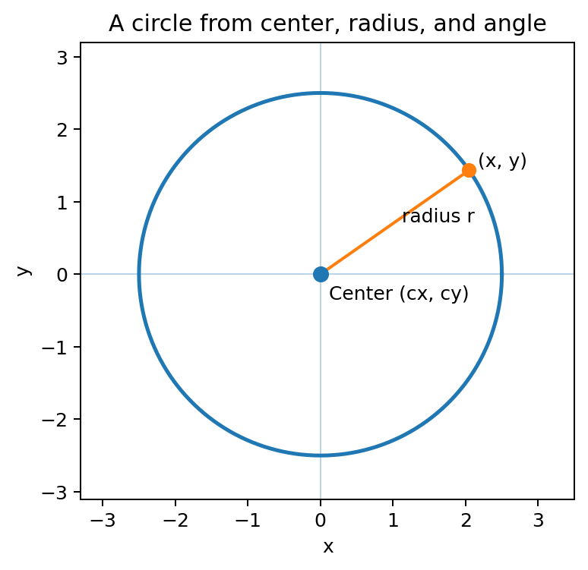
To move around the circle, use an angle θ. For each angle, calculate one x-coordinate and one y-coordinate:
x = cx + r cos(θ)
y = cy + r sin(θ)
If θ changes from 0° through 360°, the generated points travel all the way around the circle.
TEACHING NOTE Students do not need a long mathematical derivation here. The important idea is: cosine gives the horizontal offset, sine gives the vertical offset, and the radius controls their size.

Degrees and radians
C/C++ trigonometric functions such as cos() and sin() work with radians. If the loop uses degrees, convert them before calling the functions:
radian = degree × π / 180
For simple lab work, define π yourself so the program is portable across common Code::Blocks/MinGW setups:
const float PI = 3.1415926f;

2 The reusable drawCircle() function
This is the main function students should learn and reuse:
void drawCircle(float cx, float cy, float radius)
{
const float PI = 3.1415926f;
glBegin(GL_LINE_LOOP);
for (int i = 0; i < 360; i++)
{
float angle = i * PI / 180.0f;
float x = cx + radius * cos(angle);
float y = cy + radius * sin(angle);
glVertex2f(x, y);
}
glEnd();
}

Part | Meaning
cx, cy | Center position of the circle.
radius | Distance from the center to the edge.
i = 0 ... 359 | Generates points all around the circle.
angle = i × PI / 180 | Changes degrees to radians.
cos(angle) | Finds the horizontal component.
sin(angle) | Finds the vertical component.
glVertex2f(x, y) | Sends one calculated point to OpenGL.
GL_LINE_LOOP | Connects the points and automatically closes the outline.

3 Complete OpenGL / FreeGLUT program
#include <GL/glut.h>
#include <cmath>
const float PI = 3.1415926f;
void drawCircle(float cx, float cy, float radius)
{
glBegin(GL_LINE_LOOP);
for (int i = 0; i < 360; i++)
{
float angle = i * PI / 180.0f;
float x = cx + radius * cos(angle);
float y = cy + radius * sin(angle);
glVertex2f(x, y);
}
glEnd();
}
void display()
{
glClear(GL_COLOR_BUFFER_BIT);
glColor3f(1.0f, 0.0f, 0.0f);
glLineWidth(3.0f);
drawCircle(400, 300, 120);
glFlush();
}
void init()
{
glClearColor(1.0f, 1.0f, 1.0f, 1.0f);
glMatrixMode(GL_PROJECTION);
glLoadIdentity();
gluOrtho2D(0, 800, 0, 600);
}
int main(int argc, char **argv)
{
glutInit(&argc, argv);
glutInitDisplayMode(GLUT_SINGLE | GLUT_RGB);
glutInitWindowSize(800, 600);
glutCreateWindow("Regular Circle");
init();
glutDisplayFunc(display);
glutMainLoop();
return 0;
}

TEACHING NOTE For this example, drawCircle(400, 300, 120) means: center at (400,300), radius 120. Since the viewing area is 800×600, the circle appears near the middle of the window.

4 How to change the circle
Goal | What to change | Example
Move circle | Change cx and cy | drawCircle(200, 150, 80);
Make it larger | Increase radius | drawCircle(400, 300, 180);
Make it smaller | Decrease radius | drawCircle(400, 300, 50);
Change colour | Use glColor3f before drawing | glColor3f(0.0f, 0.0f, 1.0f);
Make outline thicker | Use glLineWidth | glLineWidth(5.0f);
Draw several circles | Call the function several times | drawCircle(...); drawCircle(...);

Example: three coloured circles
glColor3f(1.0f, 0.0f, 0.0f);
drawCircle(200, 300, 70);
glColor3f(0.0f, 1.0f, 0.0f);
drawCircle(400, 300, 70);
glColor3f(0.0f, 0.0f, 1.0f);
drawCircle(600, 300, 70);

Why GL_LINE_LOOP?
GL_LINE_LOOP connects each generated vertex to the next one and also connects the final vertex back to the first vertex. That makes it convenient for a closed circle outline.
TEACHING NOTE A circle is only an approximation on the display. More generated points usually make the outline look smoother. For introductory work, 360 points is simple and easy to explain.

5 Optional extension: a filled circle
If students later need a solid sun, wheel, traffic light, or button, a filled circle can be created with GL_TRIANGLE_FAN. This is still the same trigonometric point generation, not the Midpoint Circle Algorithm.
void drawFilledCircle(float cx, float cy, float radius)
{
const float PI = 3.1415926f;
glBegin(GL_TRIANGLE_FAN);
glVertex2f(cx, cy); // center point
for (int i = 0; i <= 360; i++)
{
float angle = i * PI / 180.0f;
float x = cx + radius * cos(angle);
float y = cy + radius * sin(angle);
glVertex2f(x, y);
}
glEnd();
}

The first vertex is the center. The remaining vertices go around the boundary, so OpenGL builds a fan of triangles from the center to the edge.

6 Simple objects students can make with circles
Practice object | Suggested circle use
Traffic signal | Three filled circles: red, yellow, green.
Car | Two filled or outline circles for wheels.
Sun | One yellow filled circle; add rays with lines.
Face | One large circle plus two small eye circles.
Target board | Several circles with the same center and different radii.
Bicycle | Two large circle outlines plus simple line segments.
Snowman | Three circles stacked vertically.

Student practice
- Draw one red circle at the center of an 800×600 window with radius 100.
- Draw three circles of radius 50 at x = 200, 400, and 600.
- Create a simple traffic light using three filled circles.
- Create a target board using four circles with the same center and radii 40, 80, 120, and 160.
- Create a simple car using rectangles/lines and two circles for its wheels.

Common mistakes
- Forgetting #include <cmath>, so sin() and cos() are unavailable.
- Passing degrees directly to sin() and cos() instead of converting to radians.
- Forgetting to add cx and cy, causing the circle to remain centered around the origin.
- Using GL_LINES instead of GL_LINE_LOOP and expecting OpenGL to connect every circle point automatically.
- Choosing a radius larger than the visible drawing area, so part of the circle is outside the window.
LAB FLOW Recommended teaching sequence: first run the full program unchanged; next change only the radius; then change the center; then change the colour; finally ask students to reuse the same function in a tiny design such as a traffic signal or car.

